GeoPoint is being discontinued

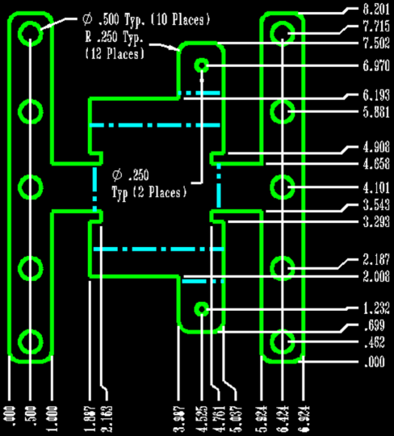
Tuesday, July 23, 2013
Hypertherm has announced the end of life of GeoPoint™, a software product for punching applications. GeoPoint has been discontinued, and effective July 23, 2013, Hypertherm will no longer sell new licenses of this product.
Customers will continue to receive activations for all GeoPoint versions for up to two years (until July 23, 2015) including moving a license. Existing GeoPoint users with an active software subscription will have full access to all support services during this time.
Hypertherm hopes that this announcement is helpful for you in planning your future software needs. If you have any questions, please contact your Hypertherm regional sales manager or channel partner.
Please continue to explore the website if you'd like more information on other Hypertherm software products, including ProNest nesting software, or Hypertherm Built for Business™ Integrated Cutting Solutions.

END

