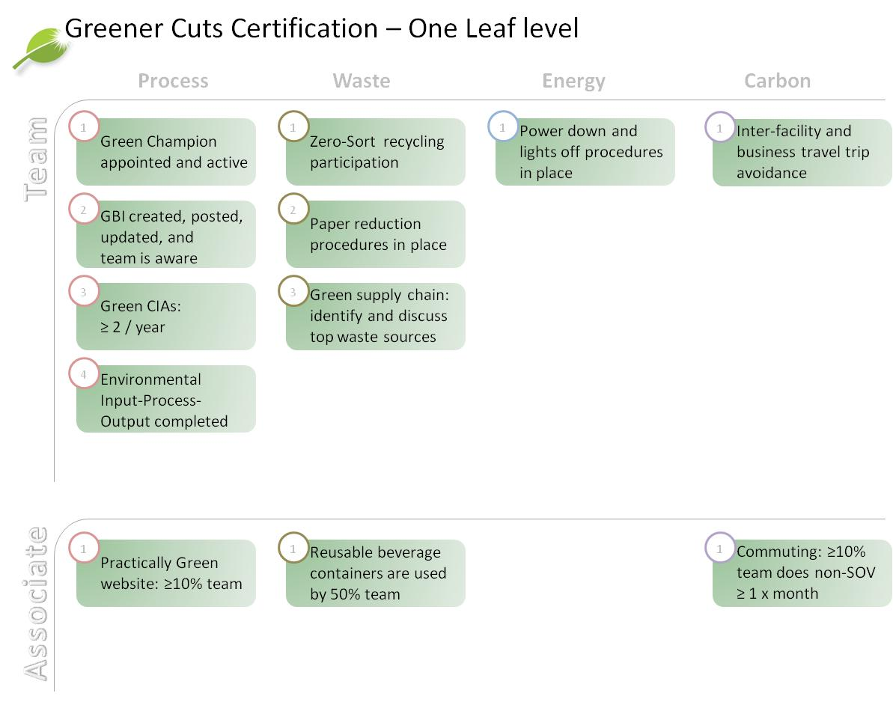

**Role and Responsibilities of Green Champion**

* Supports Team in Green Leaf Certification
* Attends Green Champ Training
* Attends semi-annual Green Champ Meeting
* Presents at the CIA walkthrough to state the progress of the GBI
* Challenges team to take steps to be more “green”
* May be involved in larger “Green” projects
* **Ambassador** for the initiative for their team
* Team Focused
* One to Two Year Term
* Volunteer Basis

**GBI Definition**

GBI’s are annual Green Business Indicators. They are a metric to measure the progress on a green initiative that your *team* has selected to work on for the year.

**Example of a Good GBI**

This is measurable and reportable (we can obtain the information readily)

*Metric:* Weekend KWH at 100 Etna Rd.

*Goal:* to reduce electricity by $10K in 2013 at 100 Etna Rd.

**Posting**

CIA board, SharePoint

[LINK to GBI Page](http://hyperweb.hypertherm.com/sites/csr/green/Lists/Green%20Business%20Indicators/AllItems.aspx)

[GBI Instructions](http://hyperweb.hypertherm.com/sites/csr/green/_layouts/15/WopiFrame.aspx?sourcedoc=/sites/csr/green/Greener%20Cuts%20Templates/GBI%20Instructions.docx&action=default)

**Updating**

Update your GBI progress to goal at least twice a year on your CIA board and post to the Green SharePoint site. There are times when it will take time to see progress toward your annual goal as you set foundations in place. The midyear CIA walkthrough is a good check toward if you will meet your year-end goal. Work with your team on needed efforts.

**CIA walkthroughs**

The Green Champ will be expected to present the GBI and progress against it at the CIA walkthrough for the team. This can be brief and serves an informational purpose for the walkthrough team: providing visibility to the GBI and the team’s work.

**Green CIA Definition**

Green CIA’s are ***actions*** or activities that have a green impact and their main purpose is to lessen Hypertherm’s negative impact on the environment. They can be actions that are in support of GBI progress or green project progress as well as independent of these efforts. It is important to note that they are not the same as the GBI, which is a metric, a measurement – Green CIA’s are actions.

The Green Team now awards a Green CIA of the Month award to Green CIA’s with the greatest cost savings, environmental impact reduction, and opportunity to be implemented in other areas of the company.

**Example of a good CIA**

“Stop printing Oracle reports and view online instead”

**Why is this good?:** It is simply implemented but will have a substantial effect on paper usage and is controlled by the ***Team***.

**Relationship to GBI?:** Perhaps the GBI for this team is to reduce paper by 25%. This is one way to impact that metric.

Note: As with all CIA’s, it is best if you can implement the CIA yourself. If you need another team’s assistance in implementation, please ask them directly.

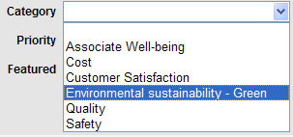

This is to be completed with environmental impacts in mind. Choose and outline the steps of any specific process or the team’s work as a whole. Think through any environmental inputs (natural resources, electricity, materials) and environmental outputs (landfill waste, recycling waste, fumes) and then work with your team for how to eliminate or reduce them. [Template](http://hyperweb.hypertherm.com/sites/csr/green/_layouts/15/WopiFrame.aspx?sourcedoc=/sites/csr/green/Greener%20Cuts%20Templates/IPO%20Template.pptx&action=default)  [Examples](http://hyperweb.hypertherm.com/sites/csr/green/_layouts/15/WopiFrame.aspx?sourcedoc=/sites/csr/green/Greener%20Cuts%20Templates/IPO%20Examples.ppt&action=default)

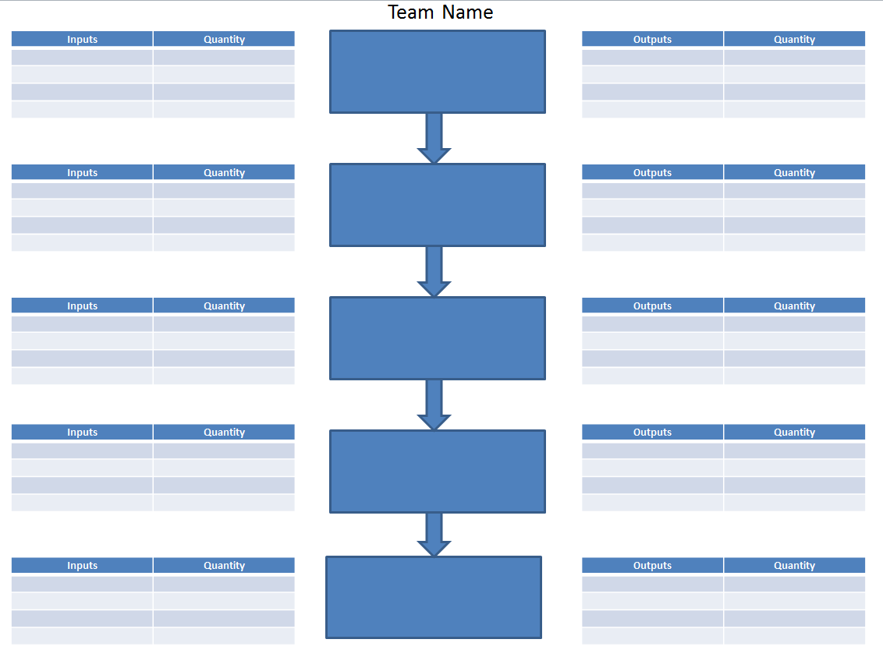

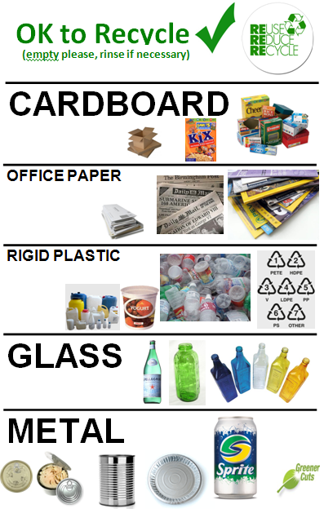

* Educate your Team about Zero-Sort, Composting, and non- rigid plastic recycling
* Actively encourage the right sorting through container placements in your team area and looking for compliance
* Make sure that new Associates know the process
* Communicate the importance of Zero-Sort and Composting and its contribution to our goal of Zero Waste, to your team.

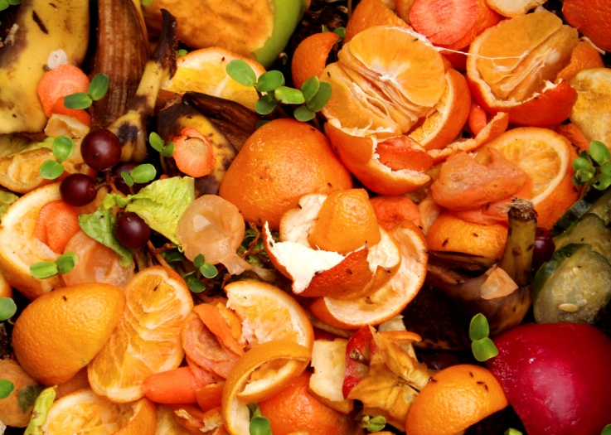

**Default Printer Settings** = double sided and black and white

Eliminate paper use whenever possible

Use of SharePoint for sharing or saving files instead of printing

Avoid printing emails

***List things for which your team uses paper. What can you do to reduce this?***

________________________________________________________________________________________________________________________________________________________________________________________________________________________________________________________________________________________________________________________________________________________________________________________________________________________________________________________________________________________________________________________________________________________________________________________________________________________________________________________________________________________________________________________________________________________________________________________________________________________________________________________________________

If your team receives any type of supplies or inputs from outside the team (can be internal to Hypertherm or external suppliers) look at the waste that is produced by that process.

**What can you do to reduce or eliminate the waste?**

* Work with Procurement to approach suppliers on improved packaging requests (reference: Incoming Packaging Database)
  1. Go through incoming parts and make a list of those that have extraneous packaging or packaging that leads to wasted time, box cutter use, or other problems.
  2. Bring this list to your team’s supply chain OR Procurement partner(s).  You can look up which supply chain or procurement partner is responsible for each part or supplier in the ERP database under “Engineering Tools” on Hyperweb.
     + That associate(s) is: __________________________
  3. Learn what plans are in place for packaging reduction in your area.
  4. Communicate upcoming packaging changes to your team and or leader.
* Ask internal suppliers to use reusable materials for shipping
* Ask internal suppliers to use recyclable materials for shipping
* If ordering something outside of the procurement process, don’t forget to ask for reduced packaging!

*Remember that Styrofoam is not recyclable at this time.*

***Make a list of the items and packaging that your team receives*** (both from internal and external sources):

________________________________________________________________________________________________________________________________________________________________________________________________________________________________________________________________________________________________________________________________________________________________________________________________________________________________________________________________________________________________________________________________________________________________________________________________________________________________________________________________________________________________________________________________________________________________________________________________________________________________________________________________________

* Create a plan for your team/area for power down, compressed air shut-off and lights off procedures.
  + Be sure to include ALL electronics and machines that are not in use while your team is not there.
  + Decide how this responsibility will be distributed throughout the team (rotations, designated person…)
* Facilities has monthly energy reports available by building for your reference

**List your Team’s items to be included in power down procedures:**

________________________________________________________________________________________________________________________________________________________________________________________________________________________________________________________________________________________________________________________________________________________________________________________________________________________________________________________________________________________________________________________________________________________________________________________________________________________________________________________________________________________________________________________________________________________________________________________________________________________________________________________________________________________________________________________________________________________________________________________________________________________________________________________________________________________________________________________________________________________________________________________________________________________________________________________________________________________________________________________________________________________________________

This involves some tracking of trips. Think of your team, including your leader. How often to you travel between facilities for meetings, events and other things. Is there a way that you can participate in certain events remotely?

To gain Certification you need to track the trips that you eliminate. This does not have to be a complicated spreadsheet but, rather, a list of those times that you “saved” a trip. [Greener Cuts Templates](http://hyperweb.hypertherm.com/sites/csr/green/Greener%20Cuts%20Templates/Forms/AllItems.aspx), [Interfacility Travel CIA's](https://hyperweb.hypertherm.com/sites/csr/green/_layouts/15/WopiFrame.aspx?sourcedoc=/sites/csr/green/Greener%20Cuts%20Templates/Inter-Facility%20CIA%20Examples.ppt&action=default)

*Example:* 7/15/2013 – 3 team members Carpooled to training at 325 Mount Support Road (HTTI)

*Example:* 4/2/2013 – held conference call instead of 3 people travelling from other buildings to the same place

**Tools for remote participation:**

*GoTo Meeting:* There are many people in the company who hold GoTo Meeting licenses. In some teams sharing one account is a feasible way to have access to this capability in an economic way. Ask your leader if anyone on your team uses this regularly and inquire about more widespread use.

*Video Conferencing:* We have equipment and capability to video conference with our other offices around the world and some of our remote associates. Schedule use of these tools with IS.

*Conference calling:* This is available on all of our phones for everyone to use. To access directions, use the Administration Team Site.

*Upon request, Microsoft Lync:* This is a tool that provides secured Instant Messaging, Video Conferencing, Virtual Meeting and PC to PC calling capability. If you are interested in installation, please contact IS. More training will be available in 2014.

**List travel avoidance opportunities for your team:**

________________________________________________________________________________________________________________________________________________________________________________________________________________________________________________________________________________________________________________________________________________________________________

10% or more of your team will view

EPA @ Home

We often are asked questions by associates of how they can learn more about being green at home. This site has some great information. There are links to click on to learn more in specific areas. If they want, associates can calculate their home carbon footprint.

10% or more of your team has explored the epa.gov/climate change site below.

<https://19january2017snapshot.epa.gov/climatechange/what-you-can-do-about-climate-change_.html>

**What are some things that you learned from completing the EPA site?**

________________________________________________________________________________________________________________________________________________________________________________________________________________________________________________________________________________________________________________________________________________________________________________________________________________________________________________________________________________________________________________________________________________________________________________________________________________________________________________________________________________________________________________________________________________________________________________________________________________________________________________________________________________________________________________________________________________________________________________________________

*Note: if you have another website or tool that you and your team like better, use it and let us know!*

In 2011, 2000 paper cups a week were used at 21 Great Hollow Road! We now have no paper cups in any of our Upper Valley buildings.

[](http://www.belairestores.com/hypertherm/store/pc/viewPrd.asp?idproduct=117&idcategory=14) 

Remember to wash them well! Soap is provided at public kitchen sinks for this purpose.

Raise awareness on your team about using reusable containers – work with your team to have their own containers available in their workspace. Use a simple list to track the usage of reusable cups. Depending on your team’s habits, you may consider tracking by exception. Choose the method that is most suitable for your team.

**My team cup usage profile (circle one)**

Travel Mug Pros Disposable Cup Devotees A Little of Both

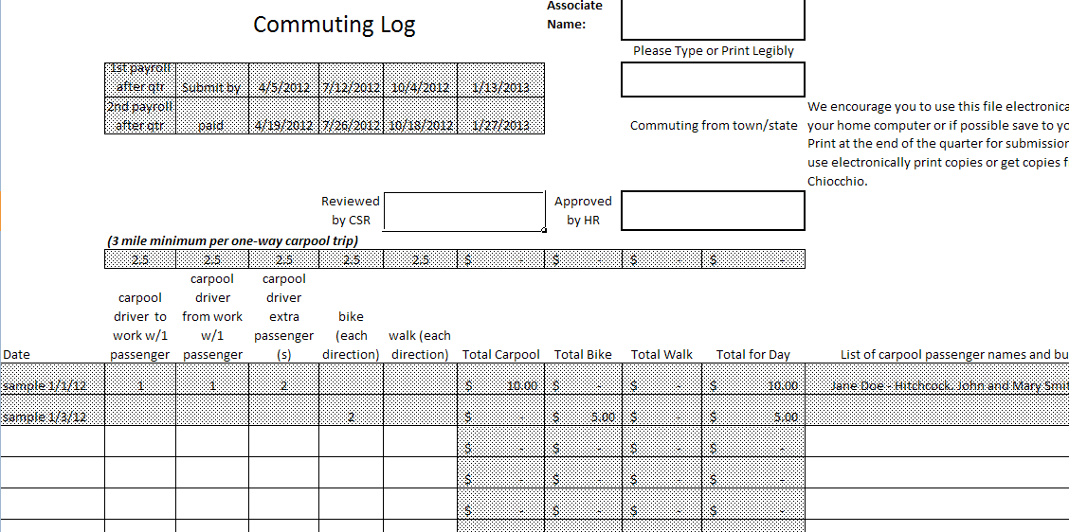

[Commuting Log](http://hyperweb.hypertherm.com/sites/csr/green/Pages/Commuting-Log.aspx)

[Commuting Resources](http://hyperweb.hypertherm.com/sites/csr/green/Commuting%20Resources/Forms/AllItems.aspx)

